The ONTARIO
PLANETARIUM
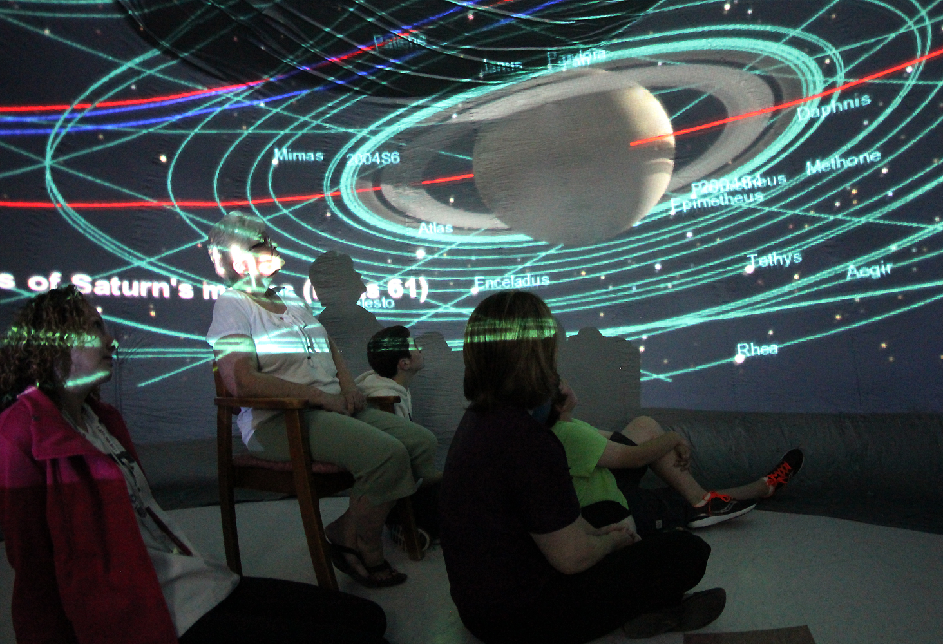

Monday, June 6
The Ontario Planetarium, a travelling domed star theatre, will be offering shows throughout the day for you to enjoy.

Location: Activities Room (sign-up required)

Showtimes:
10 am, 10:30 am, 11 am, 11:30 am, 1 pm, 1:30 pm, 2 pm, 2:30 pm, 3 pm, 3:30 pm, 4 pm (last show of the day)

